Initial estuarine response to the nutrient dense Piney Point wastewater discharge into Tampa Bay, Florida

Marcus W. Beck ([mbeck@tbep.org](mailto:mbeck@tbep.org)), Maya C. Burke ([mburke@tbep.org](mailto:mburke@tbep.org)), Emma E. Dontis ([edontis@co.pinellas.fl.us](mailto:edontis@co.pinellas.fl.us)), Jessica Lewis ([jlewis@tbep.org](mailto:jlewis@tbep.org)), Miles Medina ([miles.medina@ufl.edu](mailto:miles.medina@ufl.edu)), Elise Morrison ([elise.morrison@essie.ufl.edu](mailto:elise.morrison@essie.ufl.edu)), Mark Rains ([Mark.Rains@floridadep.gov](mailto:Mark.Rains@floridadep.gov)), Gary E. Raulerson ([graulerson@tbep.org](mailto:graulerson@tbep.org)), Sheila Scolaro ([sscolar@tbep.org](mailto:sscolar@tbep.org)), Ed T. Sherwood ([esherwood@tbep.org](mailto:esherwood@tbep.org)), David Tomasko ([dave@sarasotabay.org](mailto:dave@sarasotabay.org)), Joe Whalen ([jwhalen@tbep.org](mailto:jwhalen@tbep.org))

Last manuscript build 2021-08-29 14:49:44

# Abstract

From March 30th to April 9th, 2021, 215 million gallons of legacy phosphate mining wastewater from the Piney Point facility were released into Tampa Bay (Florida, USA). An estimated 205 tons of total nitrogen were exported to Lower Tampa Bay, exceeding typical annual external nitrogen load estimates in a matter of days. An immediate phytoplankton response was observed in samples closest to the discharge site, with chlorophyll concentrations exceeding 50 ug/L. Macroalgae blooms of cyanobacteria (*Lyngbya* spp.) were observed beginning in May, with biomass estimated at 0.5 kg/m2 at some locations. Though present south of Tampa Bay prior to the event, blooms of *Karenia brevis* were first observed in May and continued through July within Tampa Bay proper. Reported fish kills tracked bloom concentrations, prompting local cleanup efforts to remove over 1800 tons of dead fish. Combined, these observations indicate abnormal conditions in Tampa Bay following release of wastewater from Piney Point, which is supported by comparison to the decades of baseline environmental monitoring data for the region and typical seasonal conditions experienced in recent years.

*Key words*: nitrogen, phosphate mining, Tampa Bay, wastewater, water quality

# Introduction

Ecosystem management paradigms for estuaries of the Gulf Coast of Florida, USA are based primarily on the control of nutrient pollutants from atmospheric, stormwater and wastewater sources. The effects of nitrogen from dominant external source inputs are well understood as a limiting nutrient for the growth of algal blooms that can degrade water quality, having a negative effect on inter- and subtidal habitats (Greening et al., 2014; Howarth and Marino, 2006; Nixon, 1995; Parker et al., 2012). Seagrasses in particular are a primary endpoint for assessing the impacts of nutrient pollution on water quality based on established relationships between nitrogen, phytoplankton growth, water clarity, and light requirements for seagrass species observed in nearshore environments (Beck et al., 2018b; Dixon and Leverone, 1995; Greening and Janicki, 2006; Kenworthy and Fonseca, 1996). Tampa Bay is the largest estuary in Florida located in a heavily urbanized watershed of nearly 3 million individuals. Historical gains in seagrass coverage in Tampa Bay have been achieved through public-private partnerships and consensus-based approaches to science applications that seek to limit the total nutrient loads delivered to major bay segments (Greening et al., 2016; Janicki and Wade, 1996). Together, these efforts have resulted in the long-term recovery of Tampa Bay through a reduction in external nitrogen loads, improvements in water clarity, and baywide expansion of seagrass coverage to benchmark targets established for the region (Greening et al., 2014; Sherwood et al., 2017).

Ongoing threats and challenges to protecting water quality of Gulf Coast estuaries persist despite historical gains in environmental recovery. While point-source inputs of nutrient loads from wastewater treatment plants and industrial sources into Tampa Bay have been much reduced, non-point source loads from wastewater sources and stormwater runoff are estimated to dominate external nutrient loads to the bay, particularly during the rainy season from June to September (Janicki Environmental, Inc., 2017, 2008). Atmospheric deposition of nutrients from fossil fuel-based power production and automobile traffic further contribute about one-quarter of the total nitrogen inputs directly to the bay’s surface (Poor et al., 2013). Climate change stressors, such as sea level rise, changing rainfall patterns, and temperature alterations, may further perturb ecosystem dynamics and assimilative capacity by reducing system resilience to nutrient inputs (Burke, 2017; Sherwood and Greening, 2014). Many of these challenges are addressed by ongoing efforts of the US EPA National Estuary Program through implementation of a science-based resource management plan for the Bay (N. O’Hara, Shafer Consulting, Inc., 2017). The Tampa Bay Estuary Program and its partners has been instrumental in coordinating efforts among local and regional stakeholders to address legacy pollutants and current threats to the long-term protection of bay resources (Greening et al., 2016, 2014).

Wastewater byproducts from mining are a global threat to the quality of surface and groundwater resources worldwide (Hudson-Edwards et al., 2011; Tayibi et al., 2009). Phosphate fertilizer is produced through the “wet process” reaction to create phosphoric acid by treating mined phosphate rock with sulfuric acid (Burnett and Elzerman, 2001; Pérez-López et al., 2016). The process generates large amounts of waste, creating approximately one unit of phosphoric acid per five units of waste precipitate, or phosphogypsum (CaSO $​_{4}⋅$ H $​_{2}$ O). Impurities, contaminants, and radionuclides exist in phosphogypsum, making it commercially invaluable and the resulting waste is typically stored on-site in large earthen stacks (gypstacks) or holding ponds (Burnett and Elzerman, 2001). The stacks are usually near distribution centers where fertilizer is shipped elsewhere, such as port facilities close to coastal resources or population centers (Beck et al., 2018a). There are obvious environmental and human health risks associated with these stacks, primarily through controlled or uncontrolled discharge to surface waters or groundwater contamination through leaching from unlined or poorly maintained stacks. Examples exist worldwide demonstrating the potential harm of these facilities on the environment (Beck et al., 2018a; El Zrelli et al., 2015; Pérez-López et al., 2016; Sanders et al., 2013; Tayibi et al., 2009).

The geology of central Florida is rich in phosphates that have supported a multi-billion dollar mining industry for fertilizer used in food production (Henderson, 2004). By 2001, an estimated 40 million tons of phosphogypsum were created each year in northern and central Florida (Burnett and Elzerman, 2001). Currently, seventeen phosphogypsum stacks (two active, five inactive, ten closed, [Florida Department of Environmental Protection](https://geodata.dep.state.fl.us/datasets/6277c3b1eeae4a818f8683fc29e6b35b_0/about)) exist in the Tampa Bay watershed with no comprehensive, long-term plan for closure or disposal of waste to prevent unforeseen impacts to the environment. The Piney Point facility located in Palmetto, Florida is a large, remnant phosphogypsum stack located less than two miles from the shore of Tampa Bay and near two Florida aquatic preserves (Henderson, 2004). Bankruptcy of the mining company responsible for the stack in 1999 transferred ownership to a third-party, with oversight by the Florida Departmental of Environmental Protection (FDEP). Decreasing holding capacity of the ponds with seasonal rain events, tropical storms, and storage of dredging material from nearby Port Manatee have contributed to degradation of the facility. Discharges of wastewater from the stacks occurred in the early 2000s and 2011 to nearby Bishop Harbor connected to Tampa Bay. Those discharges resulted in spatially-restricted, ecosystem responses (Garrett et al., 2011; Switzer et al., 2011). Recently, FDEP authorized an [emergency order](https://floridadep.gov/sites/default/files/21-0323.pdf) on March 30th, 2021 to release wastewater from the stacks directly into lower Tampa Bay to prevent catastrophic failure of the berms supporting the holding ponds. At that time, approximately 480 million gallons of legacy phosphate mining wastewater was being held in the failing stack.

This paper provides an initial assessment of environmental conditions in Tampa Bay over five months following the recent release of 215 million gallons of legacy phosphate mining wastewater in April, 2021. The goal is to describe the results of monitoring data of surface waters collected in response to the discharge event to assess relative deviation of current conditions from long-term, seasonal records of water quality, phytoplankton, and seagrass/macroalgae datasets available for the region. We provide a brief overview of the history of the Piney Point facility, including past wastewater releases and impacts observed in Tampa Bay. A timeline of events in 2021 is also provided, which is supported by the results from 2021 response-based monitoring of conditions in and around Port Manatee, FL – the focal point of emergency discharges from the Piney Point facility. The results of this study provide an initial documentation of impacts to the natural resources of Tampa Bay that can be used to inform long-term assessments of acute wastewater discharge events on the environmental quality of the region. We focus primarily on the perspective of the Tampa Bay Estuary Program in its role in coordinating monitoring and evaluating short-term impacts, particularly in the context of long-term management goals that leverage resources from existing partnerships among local resource management institutions.

# Methods

## History of Piney Point

The Piney Point facility in Palmetto, Florida was established in 1966 by the now defunct Borden Chemicals company near Port Manatee on the southeast shore of lower Tampa Bay. Port operations were primarily for export of phosphate production by the plant. Numerous environmental issues were observed in these early years, including suspected wastewater contamination in nearby Bishop Harbor, groundwater contamination from industrial solvents, and air pollution from plant emissions (Henderson, 2004). Ownership of the facility was transferred to different companies over the course of operation and in 1993 the plant was acquired by Mulberry Phosphates, Inc., which also owned a mining facility in Mulberry, Florida to the north. In 1997, 54 million gallons of phosphate mining process water from the Mulberry plant spilled into the Alafia River, the second largest tributary to Tampa Bay, killing 1.3 million fishes and impacting 153 hectares of wetland habitat.

The Mulberry corporation filed for bankruptcy in 2001, transferring regulatory oversight of the Piney Point facility to FDEP. Although phosphate production no longer occurred at the site, focus over the next twenty years centered on containment and treatment of wastewater on-site to minimize environmental impacts. Despite these efforts, reduced holding capacities and degraded physical integrity of the holding ponds likely contributed to discharge events to surficial and ground waters. Tropical storm Gabrielle in 2001 produced 13 inches of rain, causing over 10 million gallons of wastewater to be released into Bishop Harbor, with an estimated 15.4 tons of nitrogen (pers. comm. D. Eckenrod to USEPA, Nov. 28, 2001). Species of phytoplankton associated with harmful algal blooms were observed around this time (Garrett et al., 2011). From November 2003 to October 2004, treated process water from Piney Point was discharged to Bishop Harbor to reduce the likelihood of an uncontrolled spill. Switzer et al. (2011) reported minimal impacts to nekton communities, although an increase in macroalgal blooms of *Ulva spp.* and *Gracilaria spp.* was observed as a potential indication of nutrient eutrophication. Around the same time, 248 million gallons of wastewater from Piney Point were barged 120 miles offshore to the Gulf of Mexico to reduce strain on holding capacity of storage ponds (Hu and Muller-Karger, 2003). Efforts for onsite treatment were also increased during this period to increase pH, remove heavy metals, and reduce nutrient concentrations to minimize impacts of discharge to local areas.

HRK Holdings, LLC (hereafter, HRK) acquired Piney Point in August 2006 through an administrative agreement with FDEP. This agreement transferred responsibility of the site to HRK with the intention that any future uses must protect and be compatible with the integrity of stack closure and long-term care. In 2011, HRK agreed to the storage of 1.5 million cubic yards of dredged material and seawater from Port Manatee to improve shipping capacity at the port (i.e., Berth 12 construction). This material was added to an existing, gypsumstack holding pond at Piney Point. Placement of the dredged material was suspected in compromising the liner integrity which led to an emergency discharge that released 169 million gallons of dredged saltwater slurry and 3.5 tons of nitrogen to receiving waters leading to Bishop Harbor. The dredging and deposit of slurry at Piney Point continued following structural fortifications to the holding stacks to ensure integrity with additional loadings. HRK maintains ownership and responsibility of the site to present day, with oversight by FDEP.

Legacy wastewater discharges from Piney Point did not occur again until 2021, although onsite stormwater management and discharges have occurred throughout its history. Leakages from a tear in the plastic liner of the southern holding pond (NGS-S) were suspected when water quality samples with a similar conductivity as the wastewater were detected at onsite seepage interceptor drains. The NGS-S holding pond held 480 million gallons of wastewater, as a mixture of remnant process water from phosphate production and seawater from port dredging operations. Water quality parameters of NGS-S measured in 2019 were well above baseline conditions typical of surface waters in Tampa Bay (Table 1), particularly for total phosphorus (160 mg/L) and total nitrogen (230 mg/L). Due to public safety and property concerns over catastrophic failure of the holding walls, an [emergency order](https://floridadep.gov/sites/default/files/21-0323.pdf) was issued by FDEP on March 29th for HRK to begin release of wastewater from the stack into Tampa Bay to reduce physical strain on the stacks. Unlike past discharges from the site, HRK was authorized to release wastewater through siphon lines established during dredging operations in 2011 and that discharged at Berth 12 in Port Manatee. This was done under the assumption that backwater habitats (e.g., Bishop Harbor) may be spared the impacts of additional effluent discharges from the site, as was observed in prior events. From March 30th to April 9th, approximately 215 million gallons of wastewater were released to lower Tampa Bay. Over this ten day period, an estimated 205 tons of nitrogen were delivered to the bay, exceeding contemporary annual estimates of external nutrient loads to lower Tampa Bay in a matter of days (Tampa Bay Nitrogen Management Consortium, 2010).

## Monitoring response to the emergency discharge

Monitoring of the natural resources of Tampa Bay in response to the wastewater release at Piney Point began in April, 2021 and continued over the following months. These data were collected through a coordinated effort, facilitated in part by the FDEP and TBEP. Monitoring agencies and local partners that collected data included FDEP, Environmental Protection Commission (EPC) of Hillsborough County, Parks and Natural Resources Department of Manatee County, Pinellas County Division of Environmental Management, Fish and Wildlife Research Institute of the Florida Fish and Wildlife Conservation Commission (FWC), City of St. Petersburg, TBEP, Sarasota Bay Estuary Program, Environmental Science Associates, University of South Florida, University of Florida, and New College of Florida. Monitoring efforts focused on a suite of parameters expected to respond to increased nutrient loads into the bay, which included water quality sampling (laboratory processing of discrete samples and *in situ* measurements), phytoplankton cell counts, and seagrass and macroalgae transect surveys (Figure 1). Additional samples for contaminants (e.g., heavy metals), benthic sediment, and nekton surveys were also conducted, but they are not reported here in anticipation of future monitoring events.

Established laboratory and field sample protocols for all survey methods were based on an [Interagency Monitoring Project Plan](https://drive.google.com/drive/u/0/folders/1oBGvjdve-Gpo4Kn3Ovn8a8-yVoP25eec) maintained by the TBEP in agreement with USEPA standards and those of the inter-agency partners. To the extent possible, data quality objectives followed guidelines outlined in the TBEP Data Quality Management Plan (E.T. Sherwood, G. Raulerson, M. Beck, M. Burke, 2020). Many of the local partners also participate in the Southwest Florida [Regional Ambient Monitoring Program](https://tbep.org/our-work/boards-committees/technical-advisory-committee/#ramp) that ensures similar standards and protocols are followed in the collection of monitoring data, including routine cross-reference of samples between laboratories to check precision of measured values. Discrete water quality samples were taken primarily from surface grabs by boat and processed by the respective laboratories of each participating agency. For this paper, we focus on parameters related to the nutrient management paradigm for the bay and the expected phytoplankton response from a dense, inorganic nitrogen plume entering the bay. This included evaluation of total nitrogen (mg/L), total ammonia nitrogen (NH $​_{3}$ + NH $​_{4}^{+}$, mg/L), nitrate/nitrite (NO $​_{3}^{−}$ + NO $​_{2}^{−}$, mg/L), total phosphorus (mg/L), orhophosphate (PO $​_{4}^{3−}$), and chlorophyll-a (ug/L) concentrations. Samples for pH, salinity (psu), temperature (C), and dissolved oxygen saturation (%) are also evaluated given the role these parameters can have as indicators of wastewater contamination (pH), physical drivers of primary production (salinity, temperature), and indicators of primary production and respiration (dissolved oxygen). Overall, sample effort was variable given agency resources at the time of the discharge event and over the next few months. As appropriate, water quality data were aggregated at the weekly scale and by major areas of interest (Figure 1a) given the hypothesized impacts of the discharge relative to Piney Point.

Phytoplankton samples were also collected by multiple partners and included a mix of quantitative samples enumerating major taxa by cell concentrations and qualitative presence/absence samples. Taxa were aggregated into major groups of interest for Tampa Bay, with a focus on diatoms (Bacillariophyta and other centric taxa), as common primary producers observed throughout the growing season, and species associated with harmful algal blooms (HABs), as a potentially adverse outcome of these species outcompeting others in response to nutrient inputs from Piney Point. Evaluation of HABs data included specific focus on the red tide organism *Karenia brevis* and *Pyrodinium bahamense* that can occur in the bay depending on salinity and temperature conditions during the growing season. Occurrence of both these species has historically been spatially distinct, with *K. brevis* originating in the Gulf of Mexico and occurring in higher salinity portions of the bay, whereas *P. bahamense* has been observed consistently each year since 2008 in Old Tampa Bay (northwest segment) during the summer. Data for *K. brevis* were also obtained from event-based monitoring samples collected by FWC and available from the Harmful Algal BloomS Observing System ([HABSOS](https://habsos.noaa.gov/)). Because of the increased occurrence of red tide samples in July following the emergency discharge, fish kill reports from FWC were also evaluated in relation to key municipalities (Tampa, St. Petersberg) impacted by the event. Fish kill reports were obtained from the FWC [online database](https://public.myfwc.com/fwri/FishKillReport/searchresults.aspx).

Seagrass and macroalgae transect samples were collected approximately biweekly at locations around Piney Point starting in April. Each year, the TBEP coordinates inter-agency sampling among regional partners at over sixty fixed locations throughout the bay. Because of the time-sensitive nature of the potential impacts of wastewater on seagrasses near Piney Point, the sampling protocol used at the routine monitoring locations was modified as a “rapid survey” design to sample seagrasses and macroalgae along a fifty meter transect at several of the long-term monitoring sites, as well as new locations selected along the shore and small subembayments (e.g., Bishop Harbor) to provide a more comprehensive coverage of the seagrass community near Piney Point. Seagrasses and macroalgae were identified and abundances were estimated using Braun-Blanquet cover-abundance estimates within a 50 cm $​^{2}$ quadrat at 10m distances along each transect. Dominant seagrass species in the bay include *Halodule wrightii*, *Syringodium filiforme*, and *Thalassia testudinum*. Other seagrass species (i.e., *Halophila spp.*, *Ruppia maritima*) were also observed but were present at much lower abundances and were not evaluated herein. Macroalgae taxa were aggregated by major group (i.e., red, green, and cyanobacteria) based on expected responses to nutrient pollution. Seagrasses and macroalgae abundances were converted to frequency of occurrence estimates (i.e., number of locations present divided by total locations sampled) at the transect scale or within major areas (Figure 1a) depending on the analysis described below.

## Long-term monitoring data

Water quality data in Tampa Bay have been collected at fixed sampling sites since 1974 by the Environmental Protection Commission of Hillsborough County. These data include samples at 45 stations used by the TBEP to assess annual progress towards programmatic goals and regulatory thresholds applicable for each of the major segments in Tampa Bay. Discrete water samples are collected monthly at mid-depth and processed in the laboratory immediately after collection. Similarly, the Parks and Natural Resources Department of Manatee County have been collecting data in Tampa Bay at locations south of Piney Point and south of the main dredged channel of Tampa Bay (approximate longitudinal axis of the bay). The sampling design is similar to the EPC data, with the exception that sites are sampled approximately every three months but at a higher spatial density per unit area. Additionally, the period of record for monitoring data from Manatee County began in 1996. Long-term monitoring stations for Hillsborough and Manatee Counties are shown in Figure 1a.

Long-term water quality monitoring data from Hillsborough and Manatee counties were used to establish baseline conditions for the major areas of interest in Figure 1a to compare with the response monitoring data described above. Station data from Hillsborough County were obtained for the middle and lower segments of Tampa Bay. Station data from Manatee County were obtained for areas in lower Tampa Bay, Terra Ceia Bay, Anna Maria Sound, and northern Sarasota Bay. For the same water quality parameters noted above (i.e., nitrogen, phosphorus, pH, temperature, salinity), observations at each monitoring station were averaged for each month across years from 2006 to 2020. This period represents a “recovery” stage for Tampa Bay where water quality conditions were much improved from historical conditions during a more eutrophic period and when seagrass areal coverage was trending towards and above a 1950s benchmark target of 38,000 acres (Greening et al., 2014; Sherwood et al., 2017). For each month, the mean values +/- 1 standard deviation for each parameter at each station were quantified and used as reference concentrations relative to results at the closest monitoring station that was sampled in response to Piney Point. This comparison was made to ensure that the response data were evaluated relative to stations that were spatially relevant (e.g., long-term conditions in Terra Ceia Bay are not the same as those in middle Tampa Bay) and seasonally-specific (e.g., historical conditions in April are not the same as historical conditions in August). Spatial matching of each response monitoring station relative to the long-term monitoring stations was accomplished using the “st_nearest_feature()” function from the sf R package (Pebesma, 2018). In some cases, the nearest long-term station did not include data for every monitoring parameter at a response location and the next closest station was used as a reference. These long-term water quality data are available from the University of South Florida Water Atlas (<https://wateratlas.usf.edu/>).

## Data Analysis

The R statistical programming language (v4.0.2) was used to import, synthesize, and analyze all datasets provided by multiple partners (R Core Team, 2020). Partner data were uploaded or entered manually as Google spreadsheets, where they were imported into R using the googlesheets4 (Bryan, 2020) and googledrive (D’Agostino McGowan and Bryan, 2020) R packages. The suite of R packages available in the tidyverse (Wickham et al., 2019) were used to wrangle the data into an appropriate format for analysis. The tbeptools R package (Beck et al., 2021) was used to import and summarize long-term monitoring data for Tampa Bay, specifically the EPC water quality data and seagrass transect database.

Quantitative assessments of trends included boxplot summaries, principal components analysis (PCA), Spearman rank correlations between pairs of variables, and multiple comparison tests to assess trends between months. Assessments were first evaluated only on total nitrogen, chlorophyll-a, and secchi disk depth as a general analysis of potential patterns in eutrophication following wastewater release. Further analyses were conducted to compare all data types together, including the entire suite of water quality data, seagrass frequency occurrences, and macroalgae frequency occurrences to identify potential mechanisms of change using seagrasses as an endpoint for evaluating potential impacts. Data describing *K. brevis* cell concentrations were only evaluated qualitatively because the data are from event-based sampling and generally do not represent a random sample appropriate for statistical testing. Observations for each data type were typically aggregated to the weekly or monthly scale given that sampling occurred at different days over the five month period. Spatial comparisons were based primarily on the areas identified in Figure 1a. For PCA, all variables were standardized to zero mean and unit variance so that the central tendencies and ranges of all variables were similar. Variables with log-normal distribution were log $​_{10}$-transformed (i.e., nutrients, chlorophyll) prior to analysis.

The “PCA” function from the FactoMineR R package (Lê et al., 2008) was used for PCA and the “ggord” function from the ggord R package (Beck, 2021) was used to plot the results. For total nitrogen, chlorophyll-a, and secchi depth, differences in concentrations between months within each area (Figure 1a) were evaluated using a Kruskal-Wallis one-way analysis of variance (ANOVA) followed by multiple comparisons using 2-sided Mann-Whitney U tests (Hollander et al., 2013). Probability values were adjusted using the sequential Bonferroni method described in (Holm, 1979) to account for the increased probability of Type I error rates with multiple comparisons. An adjusted p-value < 5% ( $α$ = 0.05) was considered a significant difference between months. For statistical tests using water quality data, only the monitoring results from FDEP were used for analysis given the consistency of sample location and collection date compared to the remainder of the data obtained from other partners.

# Results

## Timeline of events from April 2021

A general narrative of 2021 events in Tampa Bay following release of wastewater from Piney Point is shown in Figure 2. After the discharge stopped on April 9th, an initial phytoplankton response was observed near Piney Point with concentrations peaking around mid-April (Area 1, Figure 4b). Taxa from the Bacillariophyta phylum (diatoms) were dominant in April, with a maximum chlorophyll concentration of 265 ug/L, although median concentrations for each week in April were less than 10 ug/L. The initial diatom bloom did not persist past April. On April 20th, *K. brevis* was first observed near Anna Maria Sound at the southern edge of the mouth of Tampa Bay and reached bloom concentrations (>10k cells/L) by May 23rd, although observations were limited to lower Tampa Bay. Also during May, *Lyngbya sp.* (cyanobacteria macroalgae) were observed at high abundances in Anna Maria Sound and near Port Manatee. *Lyngbya* were observed in large floating mats on the surface and covering benthic and seagrass habitats below the water column at these locations. By June 27th, fish kill reports attributed to red tide increased with *K. brevis* cell concentrations in lower and middle Tampa Bay. The center of tropical storm Elsa passed to the west of Tampa Bay on July 5th, causing a shift in prevailing winds from the southeast. This shift contributed to an increase in fish kill reports by moving dead fish closer to heavily populated areas of Tampa Bay, specifically near the cities of St. Petersburg and Tampa. Concentrations of *K. brevis* in middle and lower Tampa Bay peaked in mid-July, with bloom conditions not observed in the bay by August. The remainder of this section is quantitative description these events.

## Water quality trends

From April to August 2021, 6503 samples were collected for chl-a, dissolved oxygen, total nitrogen, total phosphorus, total ammonia nitrogen, nitrate/nitrite, pH, salinity, secchi depth, and temperature (Table 2). Of these samples, 9.9% were outside of the normal range defined by the long-term monthly monitoring data for the baseline period from 2006 to 2020 (below for Secchi depth, above for all others). The percent of observations outside of the normal range varied by location and parameter. For chl-a, 51% of the observations were above the normal range for area 1, whereas only 9% and 24% were above for areas 2 and 3, respectively. Similarly, total nitrogen concentrations were above the normal range for 40% of observations in area 1, whereas concentrations were above for only 12% and 23% of observations in areas 2 and 3. Secchi observations for the period of observation were below the normal range for 46% of observations in area 1 and for 24% and 44% of observations in areas 2 and 3. Notable differences were also observed for dissolved oxygen (e.g., 50% were above in area 1, 48% in area 2). Physical parameters (salinity, temperature) were generally within range over the five month period. Inorganic nitrogen (ammonia, nitrate/nitrite) were generally within range, although initial time series showed much higher concentrations for ammonia in April near area 1, similar to the effluent measurements in Table 1. Spatial variation among the parameters showed that values were generally above the normal range (or below for Secchi) for many locations near Piney Point, Anna Maria Sound, and the northern mouth of Tampa Bay (Figure 3).

Boxplots of total nitrogen, chl-a, and secchi depth show the temporal progression of observations by week and area relative to the normal ranges from long-term monitoring data (Figure 4). For area 1, total nitrogen and chlorophyll concentrations were frequently above normal ranges beginning the week of April 4th and lasting through the month. Concentrations remained similar to baseline conditions until June and July when median values were often the baseline range. Secchi observations in area 1 were below baseline ranges in April and June. Observations in areas 2 and 3 were more often within the normal range, with some exceptions for total nitrogen and chl-a in area 3 during weeks of May, June, and July. Statistical comparisons between months for total nitrogen, chl-a, and secchi depth (Table 3) supported the results in Figure 4. Kruskal-Wallis tests that assessed if at least one of the months had significantly different observations for each parameter were significant for total nitrogen, chl-a, and secchi depth for area 1, total nitrogen and chl-a for area 2, and chl-a and secchi depth for area 3 (Table 3). Results of multiple comparison tests that evaluated differences between pairs of months generally showed that April/May were different from June/July depending on area and parameter. Observations in the later months were generally higher (or lower for Secchi) corresponding to increasing *K. brevis* abundances.

Multivariate assessments of all water quality parameters that combined results across weeks by area showed significant associations between groups of variables (Figure 5). The first principal component explained 41%, 74%, and 47% of the variation among water quality parameters for areas 1, 2, and 3, respectively. These components generally described a positive association between nutrients and chlorophyll concentrations and a negative association with secchi depth and dissolved oxygen. The second and third principal components explained less of the variation among water quality parameters, such that 36%, 20%, and 34% was explained by both axes for areas 1, 2, and 3, respectively. The patterns explained by these axes were less clear, although physical drivers were partially explained in some cases (e.g., component 2 for area 2 explained a positive association for salinity and temperature, Figure 5b). Spearman rank correlations between the pairs of variables used for each of the PCAs showed significant associations. Total nitrogen was positively correlated with chlorophyll and negatively associated with secchi depth for areas 1 and 2 ( $p<0.005$ and $p<0.05$, respectively). Dissolved oxygen was negatively associated with chl-a only in area 3 ($p<0.005$), although the temporal progression likely changed over time in the other areas (e.g., increase followed by decrease). Temperature generally had a positive association with chlorophyll ( $p<0.05$ for area 2, $p<0.005$ for area 3). pH was positively associated with chl-a in areas 1 and 2 ( $p<0.05$ for both).

## Seagrass and macroalgae trends

A total of 38 transects were sampled for seagrasses and macroalgae from April to August, each visited on average 1.6 times per month. Turtle grass (*T. testudinum*) was the dominant seagrass species with frequency occurrence of 51.1% across all locations and sample dates. Manatee grass (*S. filiforme*) and shoal grass (*H. wrightii*) had similar coverage across all transects, with frequency occurrences of 32.3% and 30.8%, respectively. Widgeon grass (*R. maritima*) and star grass (*H. engelmanni* and *H. decipiens*) were uncommon, with frequency occurrences of 4.1% and 0.5%. The frequency occurrences of seagrasses near Piney Point were similar to the long-term record of seagrass transect data available for Tampa Bay (Sherwood et al., 2017). At the baywide scale, shoal grass is the dominant species, whereas turtle grass is more common in euhaline waters closer to the Gulf. Macroalgae observed along the transects also varied in coverage, with red macroalgae groups having the highest frequency occurrence of 59.8%. Common taxa in the red group included *Gracilaria sp.* and *Acanthophora sp.*. Green and cyanobacteria macroalgae were less common, with frequency occurrences of 5.9% and 14.7%. Common taxa in the green group included *Ulva sp.* and *Caulerpa sp.*, whereas *Lyngbya sp.* was the only cyanobacteria macroalgae observed. Brown macroalgae in the genus *Feldmannia* were only observed at 0.2% frequency occurrence.

Temporal progression of seagrassess and macroalgae varied across the months, although a typical pattern observed at many of the transects is shown in Figure 6. Transect S3T6 is located less than one kilometer to the north of Port Manatee. The site is dominated by manatee grass that was observed at nearly all of the sample points along the transect at varying coverages. Overall abundunce of seagrass did not change dramatically from April 22nd to August 9th. However, macroalgal abundances changed over the course of sampling similar to many of the other transects sampled during the study. Red macroalgae were present in high abundances from April to May. *Lyngbya sp.* was first observed on May 24th and was present at all of the sample locations on June 4th and 15th. *Lyngbya sp.* peristed through June and July, but not was observed after July 20th. Green macroalgae taxa were first observed in July, although at generally low abundances. By August, macroalgae abundances were low. Trends in macroalgae somewhat followed seasonal patterns observed baywide with red macroalgae transitioning to green macroalgae. However, overall macroalgae trends, including June dominance of cyanobacteria was observed at nearly all transects that suggests a broader impact from wastewater discharge at Piney Point.

Monthly summaries in frequency occurrence by area (Figure 7) provided an indication of seagrass and macroalgae trends across all transects. No transects were sampled in area 2 to the north of Piney Point. Area 1 had generally balanced frequency occurrence of the three primary seagrass species observed in the bay, although a slight decrease over time in shoal grass (*H. wrightii*) was observed (April frequency occurrence of 35.4%, August frequency occurrence of 14.6%). A similar decline in coverage of shoal grass was also observed in area 3 (April frequency occurrence of 44%, July frequency occurrence of 17.4%). Frequency occurrence of manatee grass (*S. syringodium*) also declined slightly from April to July in area 3 (April frequency occurrence of 35.7%, August frequency occurrence of 13%). Changes in macroalgae frequency occurrence were much more pronounced than for seagrasses across months and by area. Red macroalgae was the dominant group across all months and areas, with the highest frequency occurrences observed in April (80.9% in area 1, 95.2% in area 3). Cyanobacteria frequency occurrence peaked in June, with greater coverage in area 3 (47.5%) compared to area 1 (29.7%). Green macroalgae had the second lowest frequency occurrence, with the highest coverage of 16.7% observed in August in area 1. Brown macroalgae was only observed at one transect.

Statistical comparisons of results in Figure 7 shown in Tables 4 and 5 further suggested that seagrass trends were minor compared to those of macroalgae. Results by month showed that seagrass frequency occurrence, by species and area, had insignificant changes ($p>0.05$) over the study period. Although trends were not significant, estimated medians in each month in Table 5 showed similar changes for seagrasses as in Figure 6, with generally higher coverage estimates in April. These changes were more pronounced in area 3 as compared to area 1. For macroalgae (Table 4), significant differences between months were observed for red and cyanobacteria macroalgae in both areas 1 and 3, although cyanobacteria differences for area 3 were only marginally significant ($p=0.041$). Coverage of cyanobacteria in area 1 during June was significantly higher than coverage in April. No significant differences between months were observed for the green macroalgae group.

## Water quality compared to seagrass and macrolagae

A PCA comparison of all water quality variables with seagrass and macroalgae frequency occurrence estimates shows significant assocations between groups of variables (Figure 8). The first principal component axis explained 31% of the variation among all variables, whereas the second and third axes explained 33% of the remaining variation. For the water quality varialbes, the first principal component axis had positive loadings for secchi depth and dissolved oyxgen and negatative assocations for total nitrogen, chl-a, and temperature. For macroalgae, the first axis was positively associated with frequency occurrence of red and green macroalgae and negatively associated with cyanobacteria. Loading vectors for the seagrasses were minor, although turtle grass (*T. testudinum*) had a weak positive association with axis 1. The second principal component axis had a strong postive assocation with total phosphorus and negative association with salinity. The third axis showed a strong positive association with manatee grass (*S. filiforme*) and negative association with shoal grass (*H. wrightii*).

Pairwise Spearman rank correlations for the same variables used in the PCA showed significant associations among several of the water quality, seagrass, and macroalgae variables. Chlorophyll-a was positively correlated with total phosphorus, total nitrogen, temperature, and pH (all $p<0.005$) and negatively correlated with secchi depth ($p<0.005$). Chlorophyll-a was also negatively correlated red and green macroalgae ($p<0.05$) and turtle grass ($p<0.005$). Among the macroalgae, green and red groups were positively correlated ($p<0.05$), whereas both were negatively correlated with cyanobacteria ( $p<0.005$ for red, $p<0.05$ for green). For water quality and seagrass, chl-a, total nitrogen, and total phosphorus was negatively correlated to turtle grass ( $p<0.005$ for all, except $p<0.05$ for total nitrogen), whereas secchi was positively associated with shoal grass ($p<0.05$). For macroalgae and seagrass, red and cyanobacteria macroalgae were positively correlated with manatee grass ( $p<0.005$ for both), whereas cyanobacteria was negatively correlated with shoal grass ($p<0.005$) and turtle grass ($p<0.05$). Among the seagrasses, manatee grass was negatively correlated with turtle grass and shoal grass ( $p<0.005$ for both).

## Red tide and fish kill reports

The increase in *K. brevis* from April to July to bloom concentrations exceeding 10k cells/L was an anomaly in 2021 that is not regularly observed in Tampa Bay. The historical record from 1995 to present in Figure 9a shows the range of cell concentrations sampled in middle and lower Tampa Bay, with only a handful of years having median cell concentrations greater than 10k cells/L, notably 2001 and 2012, although several years had concentrations above the median that were at bloom levels. Median cell concentrations for most years were well below 1k cells/L. The highest concentration of 17.6 million cells/L was observed in 2021, whereas only 2006 had a maximum observed concentration above 10 million cells/L. Seasonally in 2021, bloom concentrations were not observed until the week of May 23, with concentrations peaking by the week of July 4th, after which concentrations declined through August (Figure 9b).

Fish kill reports attributed to red tide at the cities of Tampa and Saint Petersburg, FL somewhat tracked the annual *K. brevis* cell concentrations, with a notable exception in 2021 which had the most reports among all years (Figure 9c). Historically, more fish kills were reported in Saint Petersburg (85.6%) as compared to Tampa (14.4%), where the former is closer to the mouth of Tampa Bay. In 2021, 329 reports were made in Saint Petersburg and 65 reports were made in Tampa (Figure 9d). The combined weekly reports in 2021 for Tampa and Saint Petersburg peaked the week of July 4th, the same week as the peak of *K. brevis* cell concentrations (Figure 9b). Notably, the first to last week of fish kill reports covered only one and half months, whereas red tide in the bay was observed over nearly five months. Increased reports in early July coincided with a shift in winds from Tropical Storm Elsa which moved dead fish closer to populated nearshore areas, as noted earlier. As a result, the city of St. Petersburg removed over 1800 tons of dead fish near public and private shoreline areas (K. Hammer Levy, City of St. Petersburg, pers. comm. Aug. 2021).

# Discussion

* Explain results - what’s up with inorganic nutrients? Likely driving phyto response but concentrations are not a good indicator. Uptake is rapid…
* Comparison to other locations/past events - Grand Bay, Bishop Harbor, Huelva estuary (Pérez-López et al., 2016, 2010), Dillon report about Grand Bay [link](https://www.wrri.msstate.edu/pdf/2016dillon_finalreport.pdf)
* Analysis limitations: no smoking gun but 2021 is an anomaly, additional info (benthic diversity TBD, nekton diversity TBD, large mammals, etc.), response-based monitoring may be biased
* Long-term closure plan? NGS-N is treated with spray evaporation system, but concentrations of TN/TP higher than NGS-S (see EO)/
* Potential long-term impacts TBD
* Current challenges in TB/southwest FL - OTB, seagrass loss (possibly linked to 2018 red tide, effects of Hurricanes (Tomasko et al., 2020)), red tide, climate change
* Risk of decline (IRL ex.), regression of past progress

# Acknowledgments

# Figures

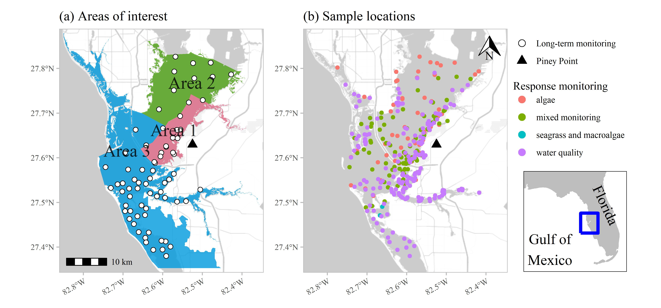

Figure 1: Areas of interest and long-term monitoring stations (a) for evaluating status and trends in response-based monitoring data and sample locations from March to July 2021 by monitoring data type (b) in response to wastewater discharge from Piney Point. Data types include algae sampling, seagrass and macroalgae, water quality (field-based and laboratory samples), and mixed monitoring (algae, seagrass and macroalgae, water quality). Inset shows location of Tampa Bay on the Gulf coast of Florida, USA.

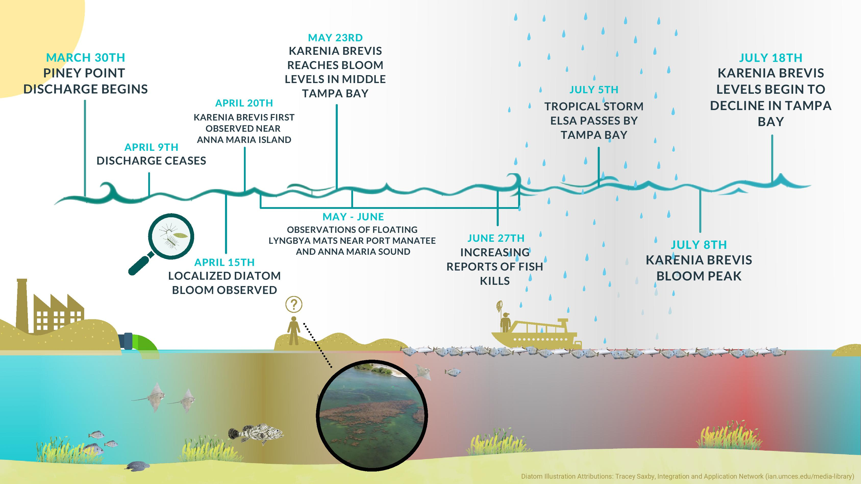

Figure 2: Graphical timeline of events from the discharge of wastewater effluent at Piney Point starting Mrach 30th, 2021 through the end of July with the gradual decline of red tide in Tampa Bay.

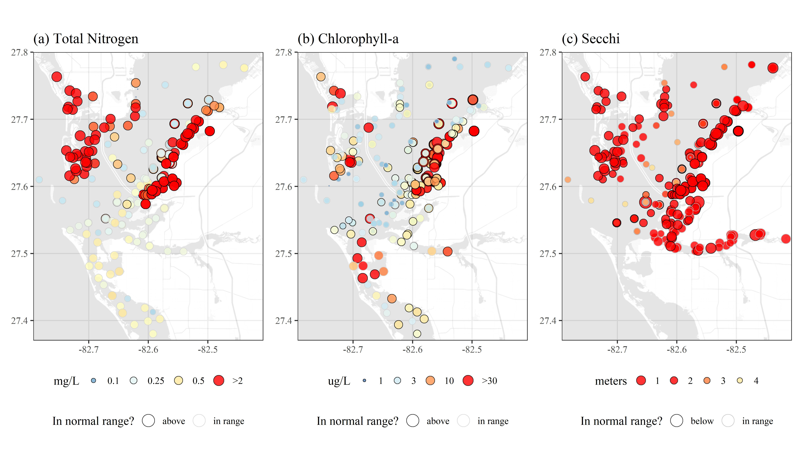

Figure 3: Sampled water quality data for April to July 2021 in response to wastewater discarge from Piney Point for (a) total nitrogen (mg/L), (b) chlorophyll-a (ug/L), and (c) secchi disk depth (meters). Values outside of the normal range (above for total nitrogen and chlorophyll, below for secchi) are outlined in black and those in normal range are outlined in light grey. Color ramps and point sizes show relative values (reversed for Secchi). Normal ranges are defined as within +/-1 standard deviation of the mean for the month of observation from 2006 to 2021 for values collected at the nearest long-term monitoring site to each sample location. Chlorophyll observations were truncated to a maximum of 30 ug/L to remove some outliers.

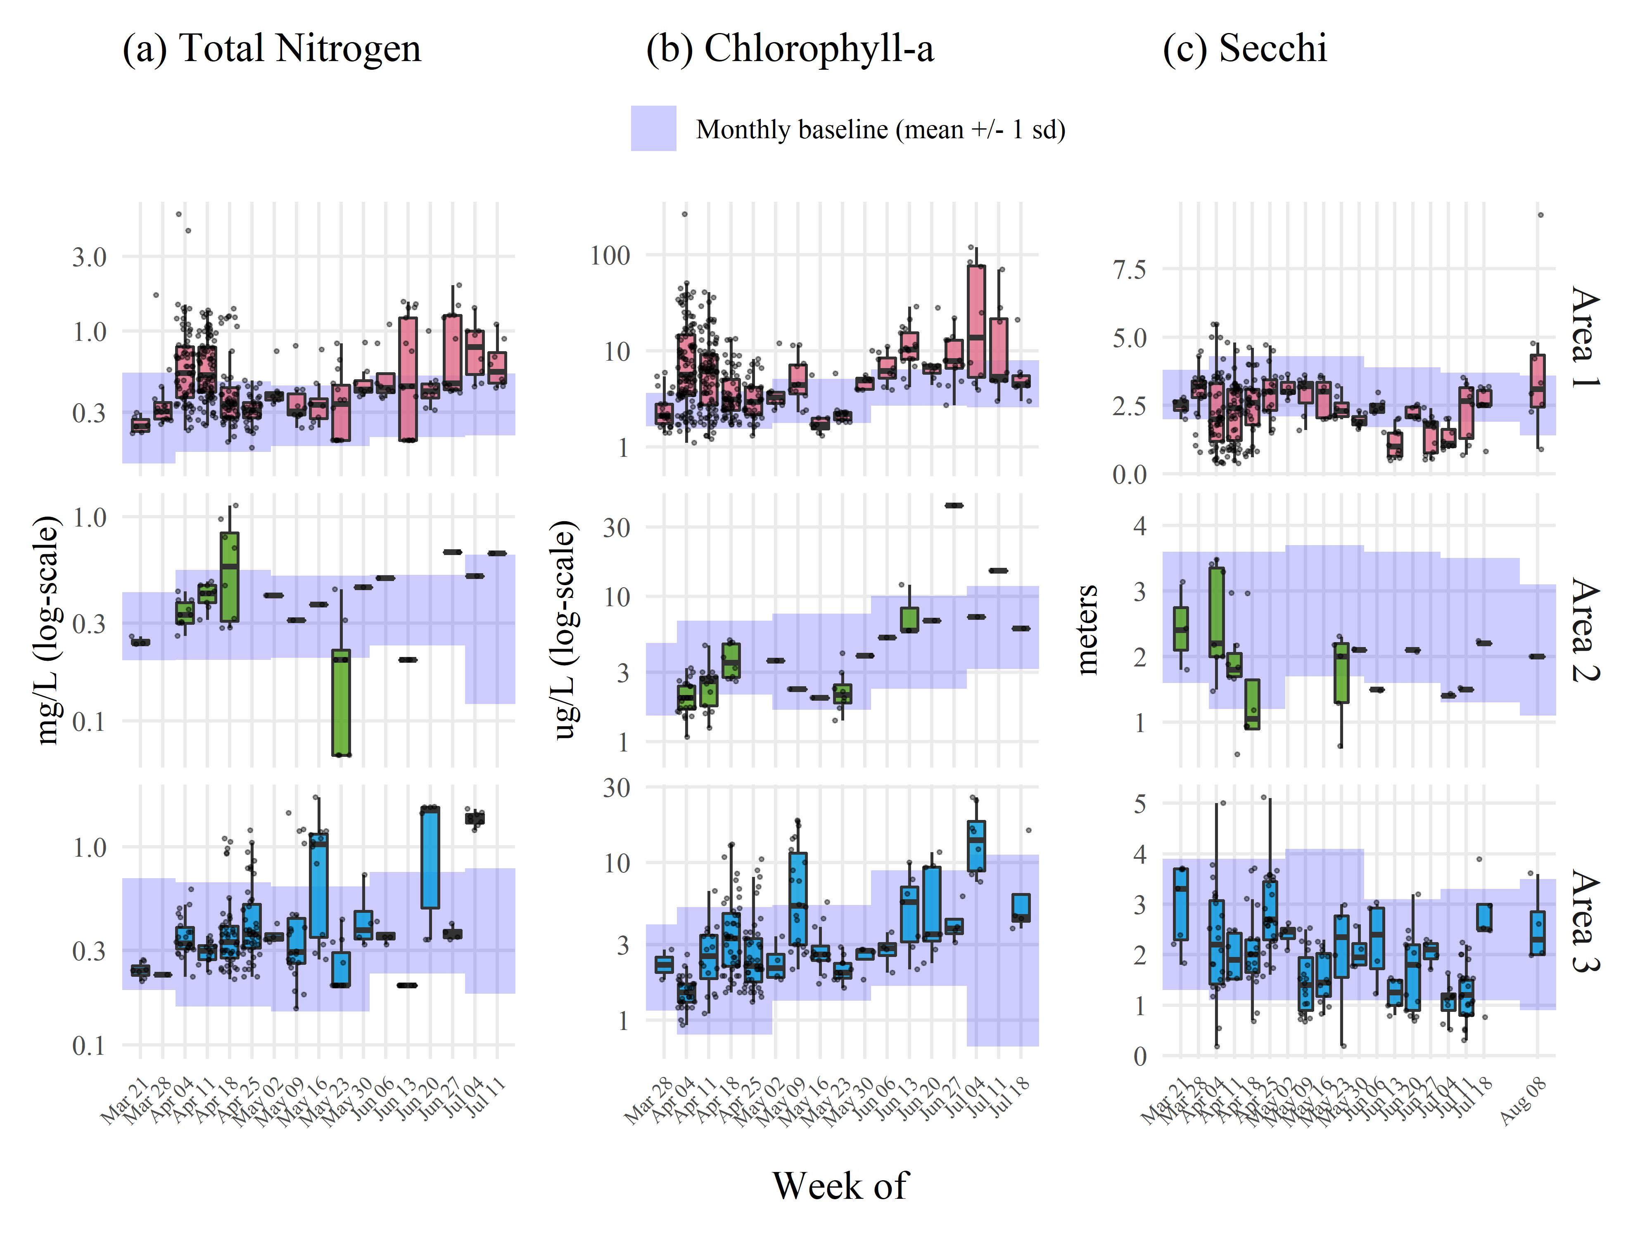

Figure 4: Sampled water quality data by week for April to July 2021 in response to wastewater discarge from Piney Point for (a) total nitrogen (mg/L), (b) chlorophyll-a (ug/L), and (c) secchi disk depth (meters). Observations are aggregated by week and within assessment areas shown in Figure 1a. Normal ranges for the month of observation (monthly baseline) and area are shown by the blue shaded areas. Normal ranges are defined as within +/-1 standard deviation of the mean for the month of observation from 2006 to 2021 for values collected at long-term monitoring sites within each area.

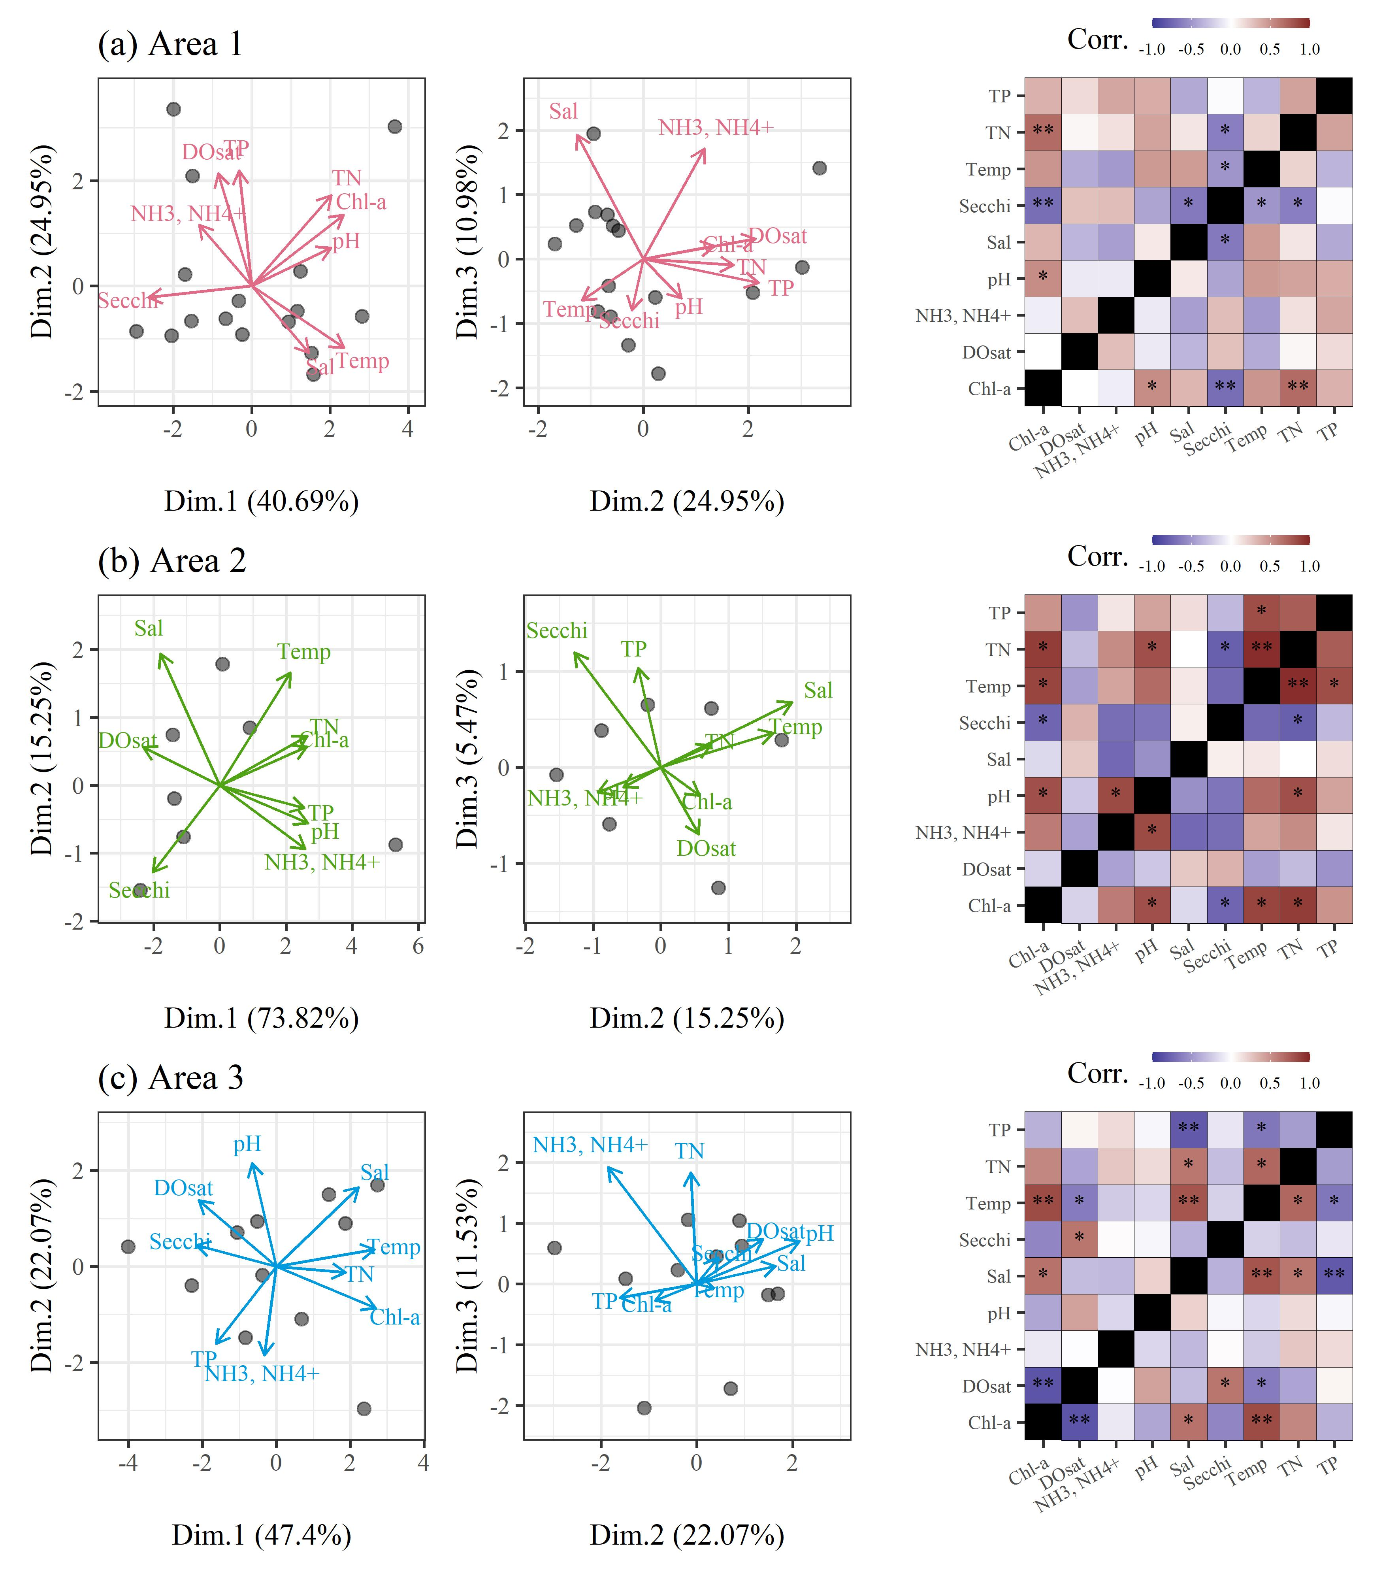

Figure 5: Principal components analyses (PCA) and correlation matrices for water quality variables by week for April to July 2021 in response to wastewater discharge from Piney Point for (a) area 1, (b) area 2, and (c) area 3 (Figure 1a). All variables were standardized to zero mean and unit variance prior to PCA. Variables with log-normal distribution were log-transformed prior to analysis. Pearson correlations indicate the linear strength of assocation between pairs of variables. ** p < 0.005, * p < 0.05, blank is not signifcant at $α$ = 0.05.

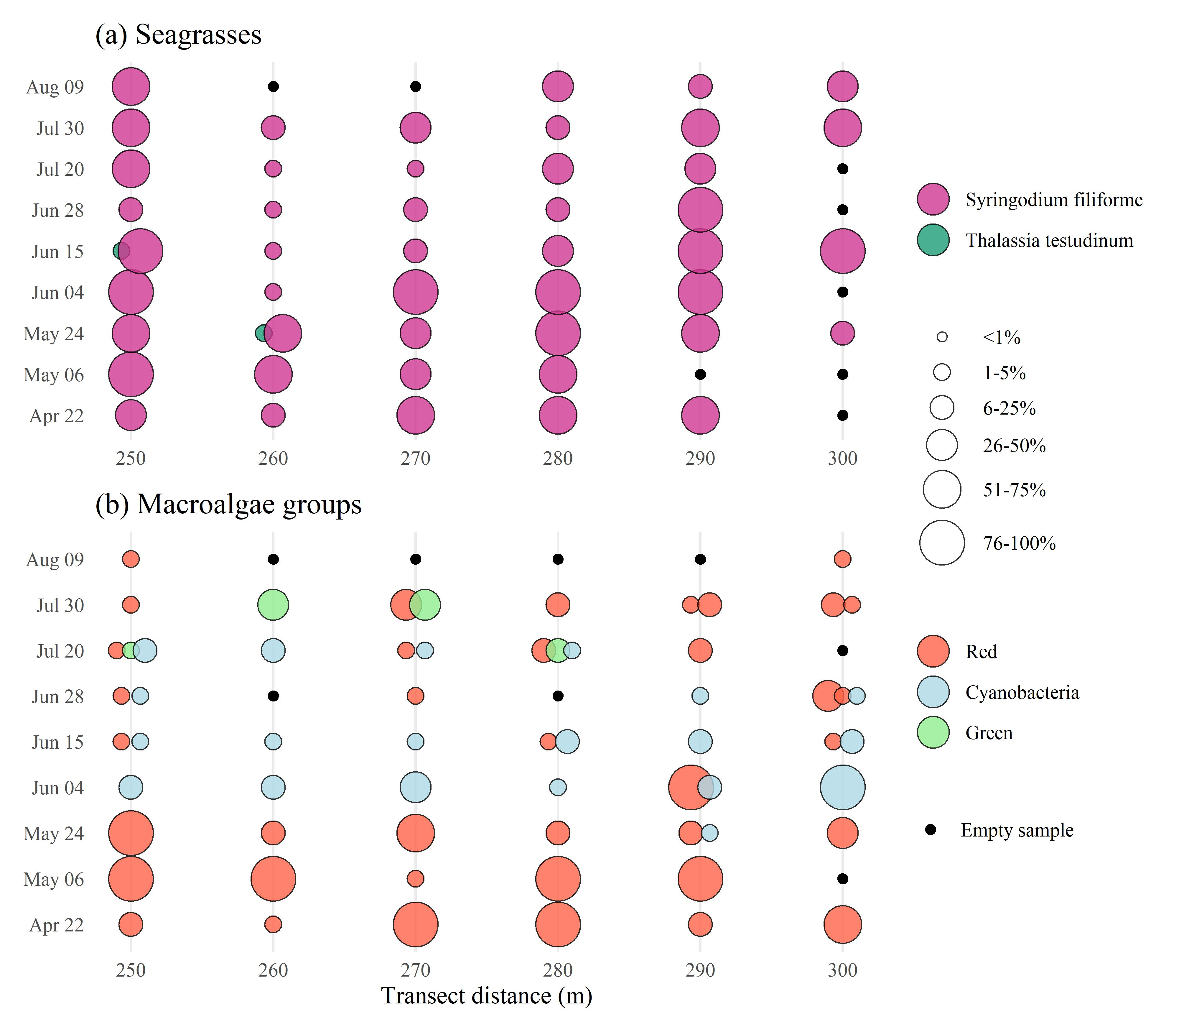

Figure 6: Results for (a) seagrass and (b) macroalgae rapid response transect surveys at a site (S3T6, -82.55866 W longitude, 27.64483 N latitude) near Piney Point. Sample dates in 2021 are shown in rows with transect meter results shown in columns. Results show dominance of manatee grass (*Syringodium filiforme*) and red macroalgae groups, with abundances of *Lyngbya sp.* (cyanobacteria) peaking in June and green macroalgae (*Ulva sp.*) increasing in July. Abundances are Braun-Blanquet coverage estimates.

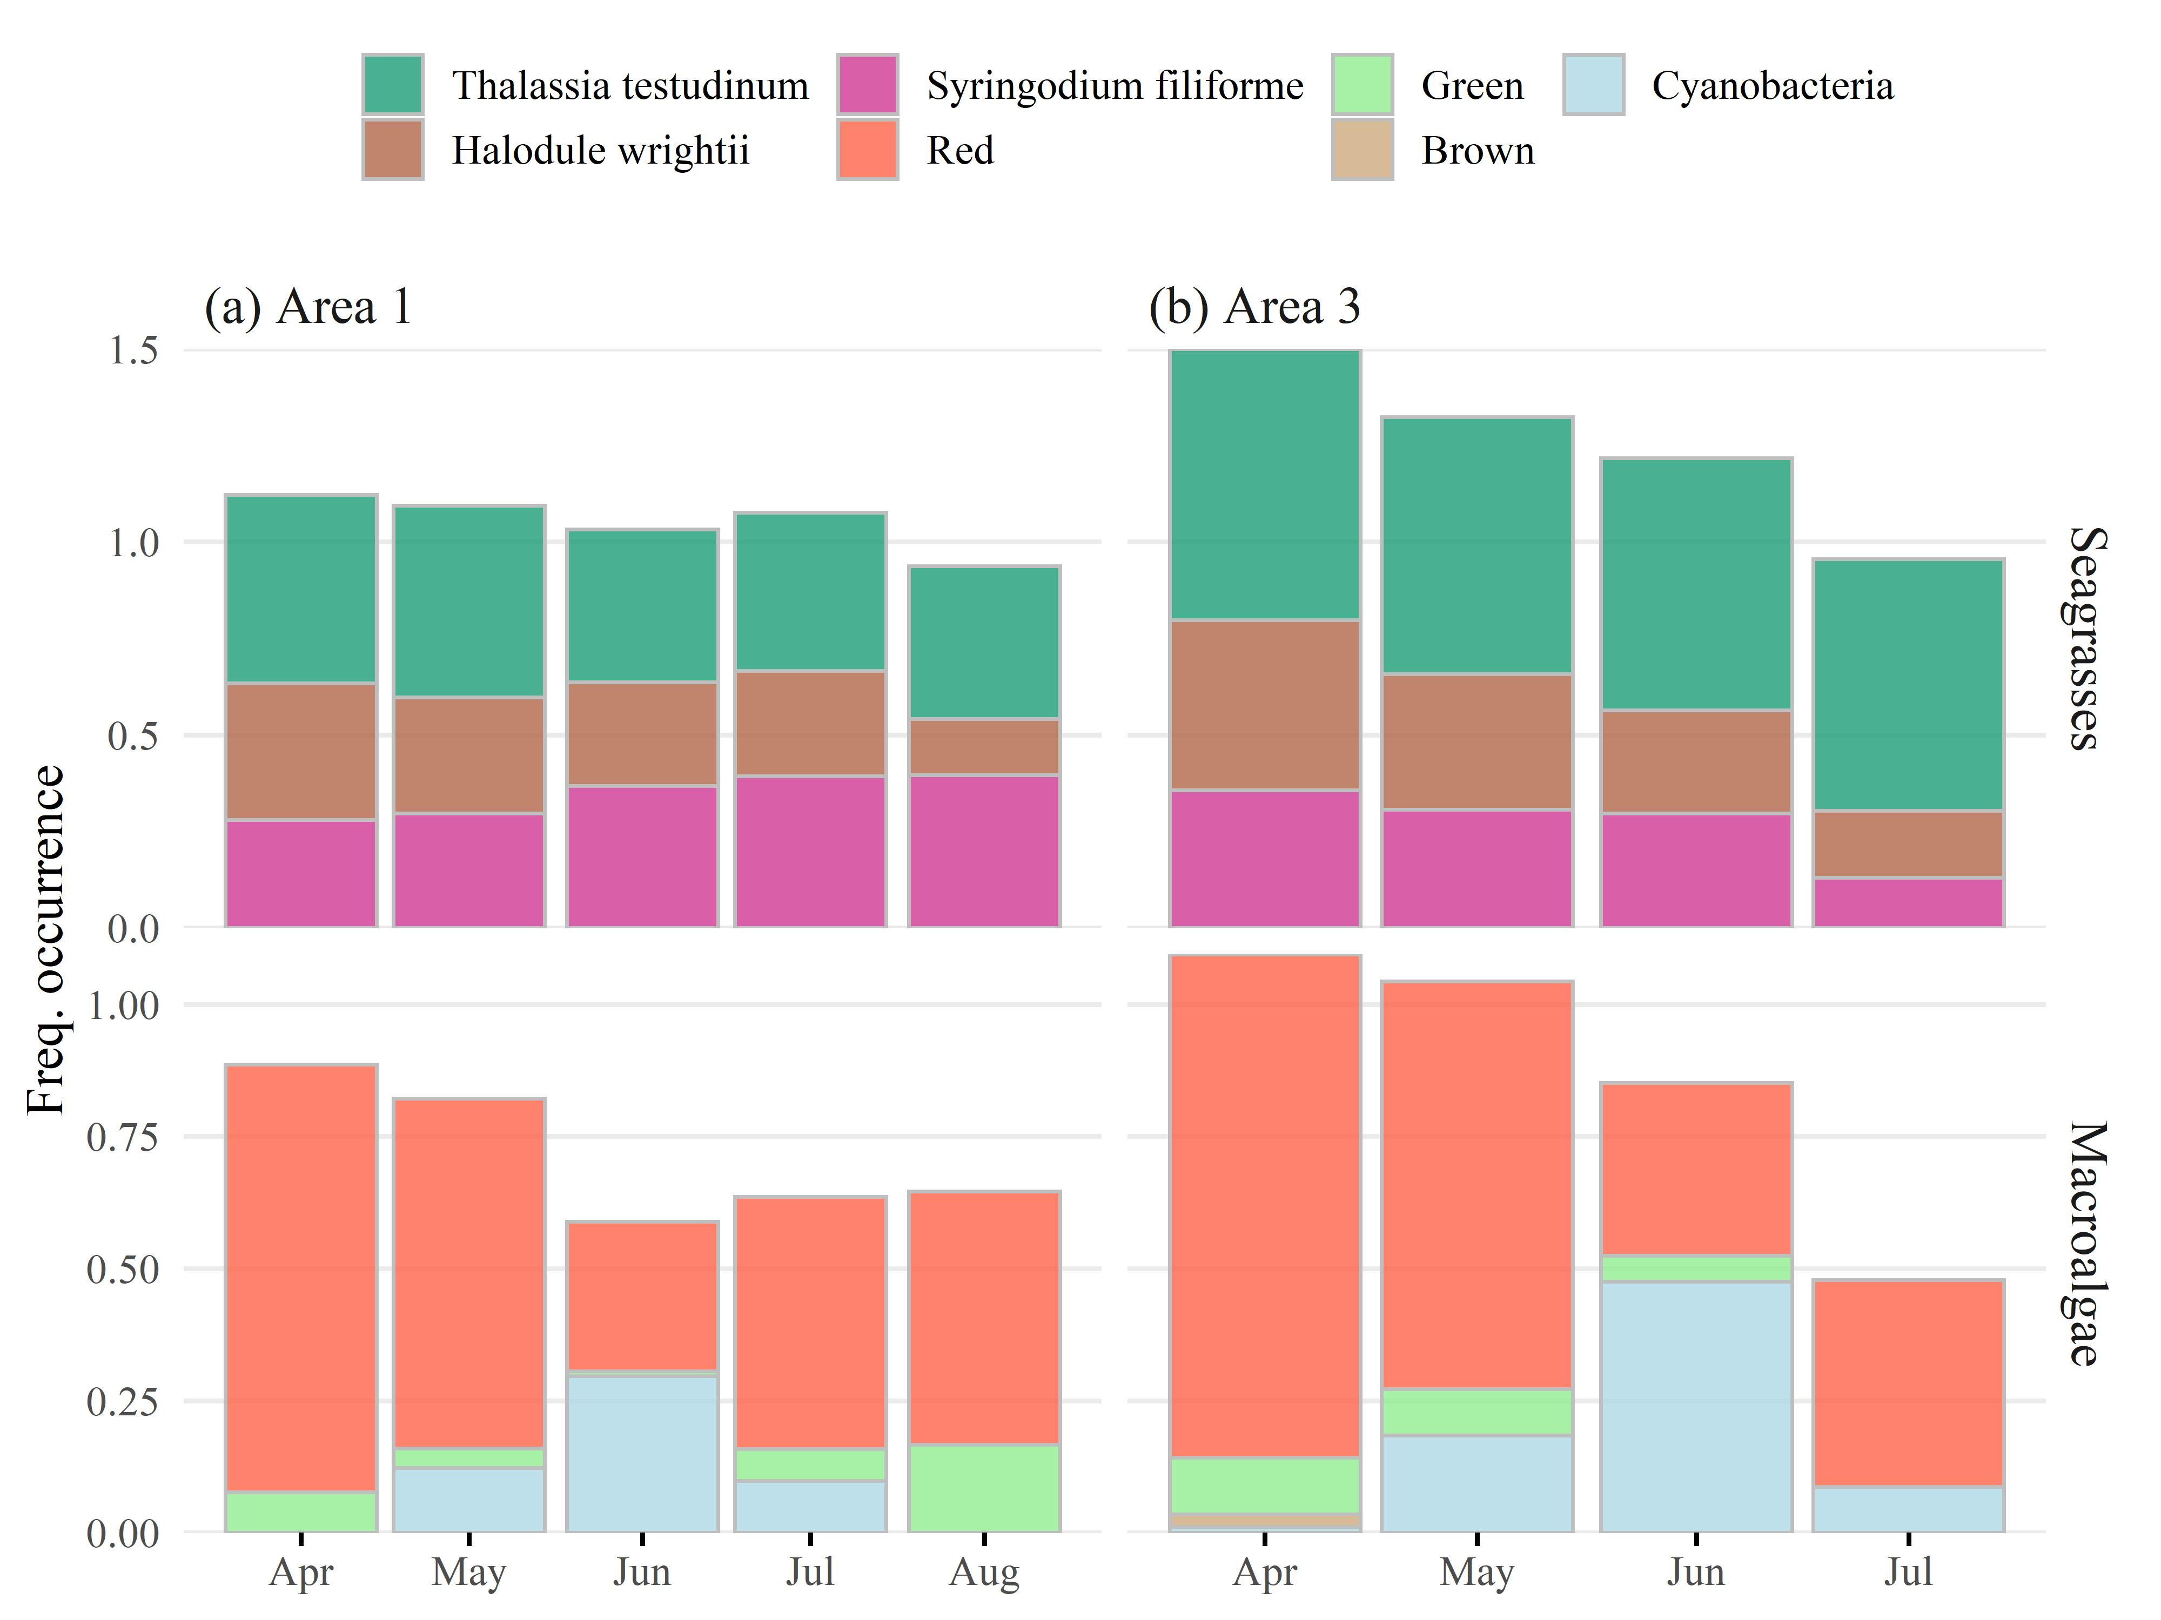

Figure 7: Frequency occurrence estimates for (a) area 1 and (b) area 2 (Figure 1a) for seagrass (top) and macroalgae (bottom) rapid response transect surveys across all transects (n = thirty-eight) near Piney Point. Estimates are grouped by sample months in 2021. Frequency occurrences are absolute for each taxa based on presence/absence.

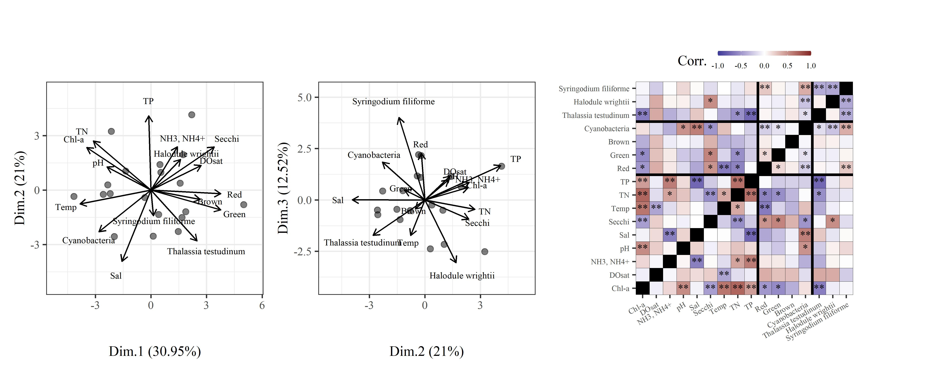

Figure 8: Principal components analysis (PCA) and correlation matrix for water quality variables, macroalgae, and seagrasses by week for April to July 2021 in response to wastewater discharge from Piney Point. Only areas 1 and 3 (Figure 1a) are included where seagrass transects were surveyed. All variables were standardized to zero mean and unit variance prior to PCA. Variables with log-normal distribution were log-transformed prior to analysis. Thick black lines in the correlation matrix separate water quality, macroalgae, and seagrass variables. Pearson correlations indicate the linear strength of assocation between pairs of variables. ** p < 0.005, * p < 0.05, blank is not significant at $α$ = 0.05.

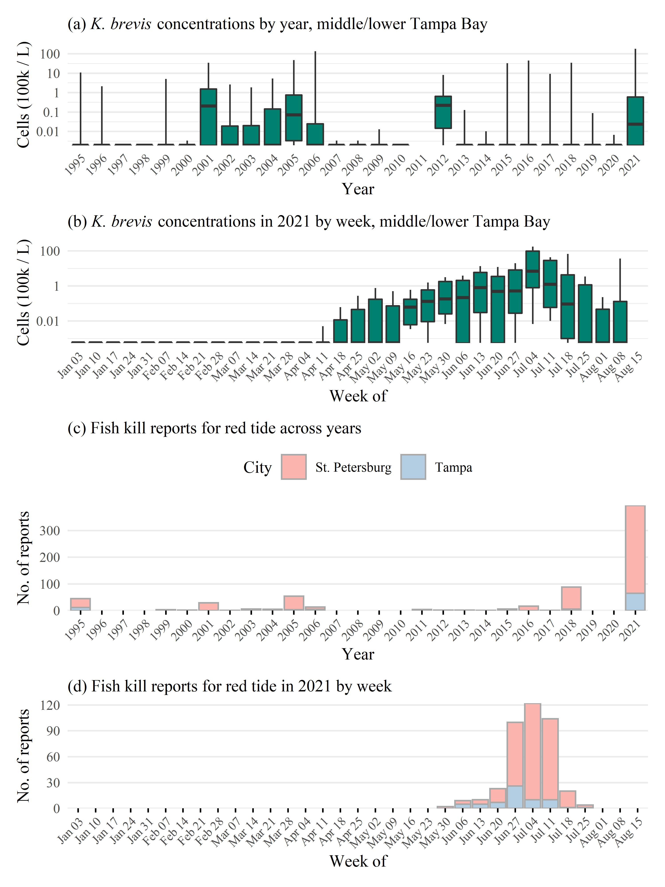

Figure 9: *Karenia brevis* concentrations (100k cells/L) and number of fish kill reports for the contiguous record showing cell concentrations (a) by year and (b) by week in 2021 and reported fish kills by city (Tampa, St. Petersburg) (c) by year and (d) by week in 2021. Red tide concentrations show minimum, tenth percentile, median, 90th percentile, and maximum for each year or week for middle and lower Tampa Bay. *K. brevis* cell counts are from NOAA Harmful Algal BloomS Observing System (HABSOS, <https://www.ncei.noaa.gov/maps/habsos>), Fish kill reports are from Florida Fish and Wildlife Conservation Commission, Fish and Wildlife Research Insitute Fish Kill Database, attributed to *K. brevis* (<https://public.myfwc.com/FWRI/FishKillReport/>).

# Tables

Table 1: Measured concentrations from the phosphogypsum stack (NGS-S) at Piney Point from a 2019 sample and end-of-pipe samples from April 2021 for relevant water quality variables. Values are compared to normal annual medians (min, max) for concentrations in lower Tampa Bay. Normal medians are based on data for a baseline period from 2006 to 2020 from long-term monitoring stations in lower Tampa Bay collected monthly by the Environmental Protection Commission of Hillsborough County. Effluent concentrations were taken from two samples on April 6th and 13th at the outflow at Port Manatee. Averages were taken when two measured values were available from both effluent sample dates. Missing values were not measured in the effluent or stack water.

|  |  |  |  |
| --- | --- | --- | --- |
| Water quality variable | 2019 stack value | 2021 end-of-pipe value | Bay median (min, max) |
| Nitrate/Nitrite (mg/L) | 0.004 | 0.292 | 0.003 (0.003, 0.018) |
| NH3, NH4+ (mg/L) | 210 | 210 | 0.019 (0.006, 0.0395) |
| TN (mg/L) | 230 | 220 | 0.286 (0.199, 0.455) |
| TP (mg/L) | 160 | 150.5 | 0.085 (0.058, 0.146) |
| Ortho-P (mg/L) | 150 | 147.5 | 0.049 (0.009, 0.055) |
| DO (% sat.) | 107.5 | - | 91 (86, 92.2) |
| pH | 4 | - | 8.1 (8, 8.1) |
| Chl-a (ug/L) | - | 105 | 3.1 (2.3, 3.5) |

Table 2: Summary of water quality variables collected from March to July 2021 in response to wastewater discharge from Piney Point. Variables are grouped by major areas interest for evaluating status and trends shown in Figure 1a. Summaries are median, maximum, and minimum values. Total observations (N obs.) and the percentage of observations in range, above, or below normal ranges are also shown. Normal ranges are defined as within +/-1 standard deviation of the mean for the month of observation from 2006 to 2021 for values collected at the nearest long-term monitoring site to each sample location.

|  |  |  |  |  |  |  |
| --- | --- | --- | --- | --- | --- | --- |
| Area | Water quality variable | Med. (Min., Max.) | N obs. | in range | above | below |
| 1 | Chl-a (ug/L) | 4.5 (1.1, 265.01) | 440 | 40.9 | 50.7 | 8.4 |
|  | DO (% sat.) | 98.4 (28.3, 215.3) | 386 | 26.9 | 49.7 | 23.3 |
|  | NH3, NH4+ (mg/L) | 0.008 (0, 14.86) | 430 | 50.2 | 23.0 | 26.7 |
|  | Nitrate/Nitrite (mg/L) | 0.01 (0, 0.14352) | 219 | 47.5 | 10.0 | 42.5 |
|  | pH | 8.1 (7, 9.1) | 432 | 47.2 | 38.7 | 14.1 |
|  | Sal (ppt) | 30.4 (12.9, 34.6) | 397 | 84.1 | 4.8 | 11.1 |
|  | Secchi (m) | 2.4 (0.4, 9.5) | 289 | 38.4 | 15.2 | 46.4 |
|  | Temp (C) | 25.3 (19.6, 32.9) | 398 | 63.3 | 19.6 | 17.1 |
|  | TN (mg/L) | 0.42 (0.178, 5.6) | 371 | 56.6 | 39.9 | 3.5 |
|  | TP (mg/L) | 0.12 (0.019, 3.9) | 439 | 59.7 | 29.6 | 10.7 |
| 2 | Chl-a (ug/L) | 2.5 (1.08, 42) | 66 | 63.6 | 9.1 | 27.3 |
|  | DO (% sat.) | 96.8 (60.6, 153.3) | 63 | 39.7 | 47.6 | 12.7 |
|  | NH3, NH4+ (mg/L) | 0.005 (0.002, 0.035) | 62 | 74.2 | 0.0 | 25.8 |
|  | Nitrate/Nitrite (mg/L) | 0.01 (0.00078, 0.014) | 41 | 90.2 | 2.4 | 7.3 |
|  | pH | 8 (7.3, 8.5) | 82 | 67.1 | 18.3 | 14.6 |
|  | Sal (ppt) | 27.6 (22.3, 32.3) | 63 | 93.7 | 0.0 | 6.3 |
|  | Secchi (m) | 2 (0.5, 3.5) | 33 | 69.7 | 6.1 | 24.2 |
|  | Temp (C) | 25 (19.9, 31.6) | 63 | 69.8 | 7.9 | 22.2 |
|  | TN (mg/L) | 0.35 (0.068, 1.13) | 49 | 71.4 | 12.2 | 16.3 |
|  | TP (mg/L) | 0.096 (0.05, 0.235) | 55 | 20.0 | 18.2 | 61.8 |
| 3 | Chl-a (ug/L) | 2.7 (0.93, 25.9) | 221 | 66.1 | 24.0 | 10.0 |
|  | DO (% sat.) | 99 (42.4, 229.9) | 197 | 52.3 | 25.9 | 21.8 |
|  | NH3, NH4+ (mg/L) | 0.008 (0.002, 0.041) | 206 | 56.3 | 0.5 | 43.2 |
|  | Nitrate/Nitrite (mg/L) | 0.01 (0.00078, 0.043) | 146 | 59.6 | 6.2 | 34.2 |
|  | pH | 8.1 (6.2, 14.4) | 220 | 62.3 | 29.5 | 8.2 |
|  | Sal (ppt) | 32.1 (1.4, 36.5) | 255 | 81.6 | 8.6 | 9.8 |
|  | Secchi (m) | 2 (0.2, 5.1) | 193 | 43.0 | 13.5 | 43.5 |
|  | Temp (C) | 25.8 (19.6, 32.1) | 255 | 58.8 | 16.1 | 25.1 |
|  | TN (mg/L) | 0.334 (0.152, 1.78) | 209 | 73.2 | 23.4 | 3.3 |
|  | TP (mg/L) | 0.061 (0.019, 0.589) | 223 | 71.3 | 17.0 | 11.7 |

Table 3: Comparison of total nitrogen, chlorophyll-a, and secchi depth by areas of interest (Figure 1a) and month. Overall signifance of differences of concentrations between months for each water quality variable and area combination are shown with Chi-squared statistics based on Kruskall-Wallis rank sum tests. Multiple comparisons with Mann-Whitney U tests (Comp column) were used to evaluate pairwise monthly concentrations for each water quality variable in each area. Rows that share a letter within each area and water quality variable combination have concentrations that are not significantly different. Probability values were adjusted for the pairwise comparisons using the Bonferroni method in Holm (1979). ** p < 0.005, * p < 0.05, blank is not signifcant at $α$ = 0.05.

|  |  |  |  |  |  |  |
| --- | --- | --- | --- | --- | --- | --- |
| Area | Water quality variable | Chi-Sq. | Comp. | Month | N obs. | Med. (Min., Max.) |
| 1 | TN (mg/L) | 26.1** | a | Apr | 135 | 0.39 (0.22, 5.6) |
|  |  |  | a | May | 32 | 0.36 (0.24, 0.83) |
|  |  |  | b | Jun | 38 | 0.43 (0.31, 1.1) |
|  |  |  | c | Jul | 16 | 0.635 (0.43, 1.4) |
|  | Chl-a (ug/L) | 41.53** | a | Apr | 144 | 3.3 (1.1, 41) |
|  |  |  | b | May | 32 | 2.4 (1.3, 12) |
|  |  |  | c | Jun | 38 | 6.6 (2.7, 28) |
|  |  |  | c | Jul | 24 | 5.5 (3, 120) |
|  | Secchi (m) | 35.74** | a | Apr | 117 | 2.9 (0.8, 5.5) |
|  |  |  | a | May | 28 | 3 (1.6, 3.6) |
|  |  |  | b | Jun | 34 | 2 (0.5, 3) |
|  |  |  | b | Jul | 24 | 2.2 (0.7, 3.5) |
| 2 | TN (mg/L) | 10.29* | a | Apr | 18 | 0.39 (0.26, 0.48) |
|  |  |  | a | May | 4 | 0.39 (0.31, 0.44) |
|  |  |  | a | Jun | 3 | 0.5 (0.45, 0.67) |
|  |  |  | a | Jul | 2 | 0.585 (0.51, 0.66) |
|  | Chl-a (ug/L) | 15.98** | a | Apr | 22 | 2.5 (1.5, 4.6) |
|  |  |  | ab | May | 4 | 2.15 (1.9, 3.6) |
|  |  |  | b | Jun | 4 | 6 (3.9, 42) |
|  |  |  | b | Jul | 3 | 7.2 (6, 15) |
|  | Secchi (m) | 1.41 | a | Apr | 14 | 2 (0.5, 3.5) |
|  |  |  | a | May | 1 | 2 (2, 2) |
|  |  |  | a | Jun | 3 | 2.1 (1.5, 2.1) |
|  |  |  | a | Jul | 3 | 1.5 (1.4, 2.2) |
| 3 | TN (mg/L) | 5.64 | a | Apr | 48 | 0.33 (0.22, 0.48) |
|  |  |  | a | May | 16 | 0.335 (0.26, 0.43) |
|  |  |  | a | Jun | 10 | 0.35 (0.32, 0.72) |
|  |  |  | a | Jul | 4 | 0.36 (0.34, 0.41) |
|  | Chl-a (ug/L) | 28.4** | a | Apr | 48 | 1.9 (1, 4.1) |
|  |  |  | ab | May | 16 | 2.35 (1.7, 3.4) |
|  |  |  | b | Jun | 12 | 2.8 (1.8, 3.6) |
|  |  |  | c | Jul | 8 | 4.15 (3.1, 16) |
|  | Secchi (m) | 12.24* | a | Apr | 41 | 2.7 (1.5, 5.1) |
|  |  |  | b | May | 16 | 2.2 (0.2, 3) |
|  |  |  | ab | Jun | 12 | 2.2 (1.2, 3.2) |
|  |  |  | ab | Jul | 12 | 2.2 (1.4, 3.9) |

Table 4: Comparison of macroalgae frequency occurrence by areas of interest (Figure 1a) and month. Overall signifance of differences of frequency occurrence between months for macroalgae groups and area combination are shown with Chi-squared statistics based on Kruskall-Wallis rank sum tests. Multiple comparisons with Mann-Whitney U tests (Comp column) were used to evaluate pairwise monthly frequency occurrences for each macroalgae group in each area. Rows that share a letter within each area and macroalgae group combination have frequency occurrences that are not significantly different. Probability values were adjusted for the pairwise comparisons using the Bonferroni method in Holm (1979). ** p < 0.005, * p < 0.05, blank is not signifcant at $α$ = 0.05.

|  |  |  |  |  |  |  |
| --- | --- | --- | --- | --- | --- | --- |
| Area | Macroalgae group | Chi-Sq. | Comp. | Month | N obs. | Med. (Min., Max.) |
| 1 | Red | 27.18** | a | Apr | 23 | 1 (0, 1) |
|  |  |  | ab | May | 24 | 0.708 (0, 1) |
|  |  |  | c | Jun | 14 | 0.121 (0, 0.722) |
|  |  |  | bc | Jul | 14 | 0.321 (0, 0.882) |
|  |  |  | abc | Aug | 8 | 0.464 (0.222, 0.857) |
|  | Green | 5.13 | a | Apr | 23 | 0 (0, 0.75) |
|  |  |  | a | May | 24 | 0 (0, 0.429) |
|  |  |  | a | Jun | 14 | 0 (0, 0.167) |
|  |  |  | a | Jul | 14 | 0 (0, 0.333) |
|  |  |  | a | Aug | 8 | 0.083 (0, 0.667) |
|  | Cyanobacteria | 21.67** | a | Apr | 23 | 0 (0, 0) |
|  |  |  | ab | May | 24 | 0 (0, 1) |
|  |  |  | b | Jun | 14 | 0.08 (0, 1) |
|  |  |  | ab | Jul | 14 | 0 (0, 0.417) |
|  |  |  | ab | Aug | 8 | 0 (0, 0) |
| 3 | Red | 18.49** | a | Apr | 7 | 0.917 (0.917, 1) |
|  |  |  | ab | May | 12 | 0.917 (0.25, 1) |
|  |  |  | c | Jun | 12 | 0.333 (0, 0.833) |
|  |  |  | bc | Jul | 4 | 0.333 (0, 0.833) |
|  | Green | 2.27 | a | Apr | 7 | 0 (0, 0.667) |
|  |  |  | a | May | 12 | 0 (0, 0.833) |
|  |  |  | a | Jun | 12 | 0 (0, 0.833) |
|  |  |  | a | Jul | 4 | 0 (0, 0) |
|  | Cyanobacteria | 8.25* | a | Apr | 7 | 0 (0, 0.083) |
|  |  |  | a | May | 12 | 0 (0, 0.833) |
|  |  |  | a | Jun | 12 | 0.167 (0, 1) |
|  |  |  | a | Jul | 4 | 0 (0, 0.4) |

Table 5: Comparison of seagrass species frequency occurrence by areas of interest (Figure 1a) and month. Overall signifance of differences of frequency occurrence between months for seagrass species and area combination are shown with Chi-squared statistics based on Kruskall-Wallis rank sum tests. Multiple comparisons with Mann-Whitney U tests (Comp column) were used to evaluate pairwise monthly frequency occurrences for each seagrass species in each area. Rows that share a letter within each area and seagrass species combination have frequency occurrences that are not significantly different. Probability values were adjusted for the pairwise comparisons using the Bonferroni method in Holm (1979). ** p < 0.005, * p < 0.05, blank is not signifcant at $α$ = 0.05.

|  |  |  |  |  |  |  |
| --- | --- | --- | --- | --- | --- | --- |
| Area | Seagrass species | Chi-Sq. | Comp. | Month | N obs. | Med. (Min., Max.) |
| 1 | Thalassia testudinum | 0.95 | a | Apr | 23 | 0.444 (0, 1) |
|  |  |  | a | May | 24 | 0.5 (0, 1) |
|  |  |  | a | Jun | 14 | 0.5 (0, 0.778) |
|  |  |  | a | Jul | 14 | 0.5 (0, 1) |
|  |  |  | a | Aug | 8 | 0.417 (0, 0.833) |
|  | Halodule wrightii | 3.36 | a | Apr | 23 | 0.25 (0, 1) |
|  |  |  | a | May | 24 | 0.167 (0, 1) |
|  |  |  | a | Jun | 14 | 0.208 (0, 0.941) |
|  |  |  | a | Jul | 14 | 0.25 (0, 1) |
|  |  |  | a | Aug | 8 | 0.083 (0, 0.667) |
|  | Syringodium filiforme | 0.55 | a | Apr | 23 | 0 (0, 1) |
|  |  |  | a | May | 24 | 0.083 (0, 1) |
|  |  |  | a | Jun | 14 | 0 (0, 1) |
|  |  |  | a | Jul | 14 | 0.083 (0, 1) |
|  |  |  | a | Aug | 8 | 0.417 (0, 1) |
| 3 | Thalassia testudinum | 0.29 | a | Apr | 7 | 1 (0, 1) |
|  |  |  | a | May | 12 | 0.875 (0, 1) |
|  |  |  | a | Jun | 12 | 0.792 (0, 1) |
|  |  |  | a | Jul | 4 | 0.617 (0.333, 1) |
|  | Halodule wrightii | 2.53 | a | Apr | 7 | 0.417 (0, 1) |
|  |  |  | a | May | 12 | 0.292 (0, 1) |
|  |  |  | a | Jun | 12 | 0.216 (0, 1) |
|  |  |  | a | Jul | 4 | 0 (0, 0.667) |
|  | Syringodium filiforme | 1.17 | a | Apr | 7 | 0.417 (0, 0.833) |
|  |  |  | a | May | 12 | 0 (0, 1) |
|  |  |  | a | Jun | 12 | 0.167 (0, 0.833) |
|  |  |  | a | Jul | 4 | 0 (0, 0.667) |

# References

Beck, M., Schrandt, M., Wessel, M., Sherwood, E., Raulerson, G., Best, B., 2021. Tbeptools: Data and indicators for the tampa bay estuary program.

Beck, M.W., 2021. Ggord: Ordination plots with ggplot2.

Beck, M.W., Cressman, K., Griffin, C., Caffrey, J., 2018a. Water quality trends following anomalous phosphorus inputs to Grand Bay. Gulf and Caribbean Research 29, 1–14. <https://doi.org/10.18785/gcr.2901.02>

Beck, M.W., Hagy, J.D., III, Le, C., 2018b. Quantifying seagrass light requirements using an algorithm to spatially resolve depth of colonization. Estuaries and Coasts 41, 592–610. <https://doi.org/10.1007/s12237-017-0287-1>

Bryan, J., 2020. googlesheets4: Access google sheets using the sheets API V4.

Burke, M., 2017. CCMP Climate Change Vulnerability Assessment (No. 10b-17). Tampa Bay Estuary Program, St. Petersburg, Florida.

Burnett, W.C., Elzerman, A.W., 2001. Nuclide migration and the environmental radiochemistry of florida phosphogypsum. Journal of Environmental Radioactivity 54, 27–51. <https://doi.org/10.1016/S0265-931X(00)00164-8>

D’Agostino McGowan, L., Bryan, J., 2020. Googledrive: An interface to google drive.

Dixon, L.K., Leverone, J.R., 1995. Light requirements of *thalassia testudinum* in Tampa Bay, Florida. Number 425, Mote Marine Lab, Sarasota, Florida.

E.T. Sherwood, G. Raulerson, M. Beck, M. Burke, 2020. Tampa Bay Estuary Program: Quality Management Plan (No. 16-20). Tampa Bay Estuary Program, St. Petersburg, Florida.

El Zrelli, R., Courjault-Radé, P., Rabaoui, L., Castet, S., Michel, S., Bejaoui, N., 2015. Heavy metal contamination and ecological risk assessment in the surface sediments of the coastal area surrounding the industrial complex of Gabes city, Gulf of Gabes, SE Tunisia. Marine pollution bulletin 101, 922–929. <https://doi.org/10.1016/j.marpolbul.2015.10.047>

Garrett, M., Wolny, J., Truby, E., Heil, C., Kovach, C., 2011. Harmful algal bloom species and phosphate-processing effluent: Field and laboratory studies. Marine Pollution Bulletin 62, 596–601. <https://doi.org/10.1016/j.marpolbul.2010.11.017>

Greening, H., Janicki, A., 2006. Toward reversal of eutrophic conditions in a subtropical estuary: Water quality and seagrass response to nitrogen loading reductions in Tampa Bay, Florida, USA. Environmental Management 38, 163–178. <https://doi.org/10.1007/s00267-005-0079-4>

Greening, H., Janicki, A., Sherwood, E., 2016. Seagrass recovery in Tampa Bay, Florida (USA), in: Finlayson, C.M., Milton, G.R., Prentice, R.C., Davidson, N.C. (Eds.), The Wetland Book. Springer, Berlin, Germany, pp. 1–12.

Greening, H., Janicki, A., Sherwood, E., Pribble, R., Johansson, J.O.R., 2014. Ecosystem responses to long-term nutrient management in an urban estuary: Tampa Bay, Florida, USA. Estuarine, Coastal and Shelf Science 151, A1–A16. <https://doi.org/10.1016/j.ecss.2014.10.003>

Henderson, C.S., 2004. Piney Point phosphate plant: An environmental analysis.

Hollander, M., Wolfe, D.A., Chicken, E., 2013. Nonparametric statistical methods. John Wiley & Sons.

Holm, S., 1979. A simple sequentially rejective multiple test procedure. Scandinavian journal of statistics 65–70.

Howarth, R.W., Marino, R., 2006. Nitrogen as the limiting nutrient for eutrophication in coastal marine ecosystems: Evolving views over three decades. Limnology and oceanography 51, 364–376. https://doi.org/<https://doi.org/10.4319/lo.2006.51.1_part_2.0364>

Hu, C., Muller-Karger, F.E., 2003. Satellite monitoring of the FDEP Gulf dispersal of the Piney Point treated wastewater. University of South Florida, Institute for Marine Remote Sensing, St. Petersburg, Florida.

Hudson-Edwards, K.A., Jamieson, H.E., Lottermoser, B.G., 2011. Mine wastes: Past, present, future. Elements 7, 375–380. <https://doi.org/10.2113/gselements.7.6.375>

Janicki, A., Wade, D., 1996. Estimating critical external nitrogen loads for the Tampa Bay estuary: An empirically based approach to setting management targets (No. 06-96). Tampa Bay National Estuary Program, St. Petersburg, Florida.

Janicki Environmental, Inc., 2017. Estimates of total nitrogen, total phosphorus, total suspended solids, and biological oxygen demand loadings to Tampa Bay, Florida: 2012-2016 (No. 04-17). Tampa Bay Estuary Program, St. Petersburg, Florida.

Janicki Environmental, Inc., 2008. Estimation of nitrogen loading from residential irrigation. Tampa Bay Estuary Program, St. Petersburg, Florida.

Kenworthy, W.J., Fonseca, M.S., 1996. Light requirements of seagrasses *halodule wrightii* and *syringodium filiforme* derived from the relationship between diffuse light attenuation and maximum depth distribution. Estuaries 19, 740–750.

Lê, S., Josse, J., Husson, F., 2008. FactoMineR: A package for multivariate analysis. Journal of Statistical Software 25, 1–18. <https://doi.org/10.18637/jss.v025.i01>

N. O’Hara, Shafer Consulting, Inc., 2017. Charting the course: The comprehensive conservation and management plan for Tampa Bay (No. 10-17). Tampa Bay Estuary Program, St. Petersburg, Florida.

Nixon, S.W., 1995. Coastal marine eutrophication: A definition, social causes, and future concerns. Ophelia 41, 199–219. <https://doi.org/10.1080/00785236.1995.10422044>

Parker, A.E., Hogue, V.E., Wilkerson, F.P., Dugdale, R.C., 2012. The effect of inorganic nitrogen speciation on primary production in the San Francisco Estuary. Estuarine, Coastal, and Shelf Science 104, 91–101.

Pebesma, E., 2018. Simple features for R: Standardized support for spatial vector data. The R Journal 10, 439–446. <https://doi.org/10.32614/RJ-2018-009>

Pérez-López, R., Macı́as, F., Cánovas, C.R., Sarmiento, A.M., Pérez-Moreno, S.M., 2016. Pollutant flows from a phosphogypsum disposal area to an estuarine environment: An insight from geochemical signatures. Science of the Total Environment 553, 42–51. <https://doi.org/10.1016/j.scitotenv.2016.02.070>

Pérez-López, R., Nieto, J.M., López-Coto, I., Aguado, J.L., Bolı́var, J.P., Santisteban, M., 2010. Dynamics of contaminants in phosphogypsum of the fertilizer industry of Huelva (SW Spain): From phosphate rock ore to the environment. Applied Geochemistry 25, 705–715. <https://doi.org/10.1016/j.apgeochem.2010.02.003>

Poor, N., Cross, L., Dennis, R., 2013. Lessons learned from the Bay Region Atmospheric Chemistry Experiment (BRACE) and implications for nitrogen management of Tampa Bay. Atmospheric Environment 70, 75–83. <https://doi.org/10.1016/j.atmosenv.2012.12.030>

R Core Team, 2020. R: A language and environment for statistical computing, v4.0.3. R Foundation for Statistical Computing, Vienna, Austria.

Sanders, L., Luiz-Silva, W., Machado, W., Sanders, C.J., Marotta, H., Enrich-Prast, A., Bosco-Santos, A., Boden, A., Silva-Filho, E., Santos, I.R., others, 2013. Rare earth element and radionuclide distribution in surface sediments along an estuarine system affected by fertilizer industry contamination. Water, Air, & Soil Pollution 224, 1–8. <https://doi.org/10.1007/s11270-013-1742-7>

Sherwood, E., Greening, H., 2014. Potential impacts and management implications of climate change on Tampa Bay estuary critical coastal habitats. Environmental Management 53, 401–415. <https://doi.org/10.1007/s00267-013-0179-5>

Sherwood, E., Greening, H., Johansson, J.O.R., Kaufman, K., Raulerson, G., 2017. Tampa Bay (Florida, USA): Documenting seagrass recovery since the 1980’s and reviewing the benefits. Southeastern Geographer 57, 294–319. <https://doi.org/10.1353/sgo.2017.0026>

Switzer, T.S., Tyler-Jedlund, A.J., Rogers, K.R., Grier, H., McMichael Jr, R.H., Fox, S., 2011. Response of estuarine nekton to the regulated discharge of treated phosphate-production process water. Florida Fish; Wildlife Conservation Commission, Fish; Wildlife Research Institute, St. Petersburg, Florida.

Tampa Bay Nitrogen Management Consortium, 2010. 2009 Reasonable Assurance Addendum: Allocation and Assessment Report: Appendix B (No. 03a-10). Tampa Bay Estuary Program, St. Petersburg, Florida.

Tayibi, H., Choura, M., López, F.A., Alguacil, F.J., López-Delgado, A., 2009. Environmental impact and management of phosphogypsum. Journal of Environmental Management 90, 2377–2386. <https://doi.org/10.1016/j.jenvman.2009.03.007>

Tomasko, D., Alderson, M., Burnes, R., Hecker, J., Iadevaia, N., Leverone, J., Raulerson, G., Sherwood, E., 2020. The effects of Hurricane Irma on seagrass meadows in previously eutrophic estuaries in Southwest Florida (USA). Marine Pollution Bulletin 156, 111247. <https://doi.org/10.1016/j.marpolbul.2020.111247>

Wickham, H., Averick, M., Bryan, J., Chang, W., McGowan, L.D., François, R., Grolemund, G., Hayes, A., Henry, L., Hester, J., Kuhn, M., Pedersen, T.L., Miller, E., Bache, S.M., Müller, K., Ooms, J., Robinson, D., Seidel, D.P., Spinu, V., Takahashi, K., Vaughan, D., Wilke, C., Woo, K., Yutani, H., 2019. Welcome to the tidyverse. Journal of Open Source Software 4, 1686. <https://doi.org/10.21105/joss.01686>